Project report
Introduction
As text storage increases data of text is also increasing. Therefore, many natural language processing techniques are developed to help people facilitate their jobs, such as spam classification, sentiment analysis, spelling correction, etc.
Background
Thanks to the following work, our group had an idea and the workflow on how to conduct this project: Sentiment analysis. This is a Natural Language Processing project of which focus is on sentiment analysis. We would like to extract meaningful phrases from reviews and classify them into most important features (and possibly their ratio) that hotels need to distribute their resources accordingly.
Reference link: https://algorithmia.com/blog/introduction-sentiment-analysis

Model
Architecture diagram
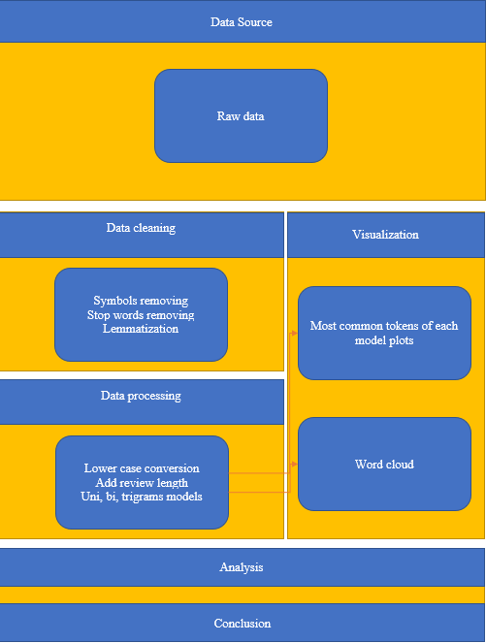

Workflow diagram
- Raw data:
  - Importing data in csv format
- Reviews cleaning
  - Removing symbols
  - Removing stop words
  - Lemmatization
- Lower case conversion
  - Converting the content of reviews to lower case for uniformity
- Adding a column to review length
  - This is to help find the relation between ratings and reviews
- Get ngrams model tokens
  - Unigram
  - Bigram and trigram models are also used for clarification of reviews. For example, “good” is not useful while “good service” or “good customer service” help
- Most common tokens visualization
  - This is to see how frequent tokens are mentioned in reviews
- Word Cloud
  - This has the same purpose with the previous step. The difference is that some audiences are familiar with it. The disadvantage is that it only works with unigram tokens
- Categorizing most common tokens
  - This step is to find the similarity of the most common tokens with standard criteria of hotels.
- Calculating percentage of each criterion
  - The frequency of the most common tokens in each criterion is a primary part of the computation.
- Using the mean of percentage of three ngrams models for conclusion.

Dataset
Description
The dataset was taken from Kaggle: https://www.kaggle.com/andrewmvd/trip-advisor-hotel-reviews which includes 20491 rows x 2 columns where rows represent reviews of customers who have experienced hotel services and columns are of the review content and their ratings.
Design of features
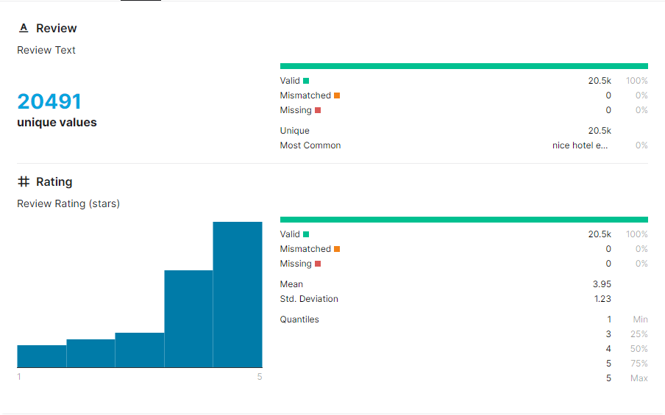

Analysis of data
Data preprocessing:
- A list of stop words is extracted from Spacy library
- Regex library helps clean meaningless symbols (function re.sub)
- Inflected forms of words are grouped by Spacy tokens
- Vectorization, a technique that makes use of numpy array helps in conducting the three jobs, and also creating another column: review length.
Graph model

Implementation
Algorithm
Function clean_data(raw_data: str):
“This function cleans a string text by, removing symbols, removing stop words, and converting words to its original form, and”
Raw_data symbols removed lemmatization Stop words removed
Return cleaned_data
Function get_most_commons(array_of_text: list, n_grams_model):
“This function returns an array of text to a list of tuple of (the counted token, its frequency) in the text in a form of n_grams_model (unigram, bigram, trigram, etc.)”
array_of_text string_of_text list_of_tokenized_ngrams
Counter(list_of_tokenized_ngrams)
return list(tuple(counted_words, frequency))
Function to_pandas_dataframe(list):
“This function turns a list of tuple of two elements to a pandas table format with two columns: token and frequency”
Return DataFrame(data = list, columns = ['token', 'frequency'])
Function criteria_ratio(list_of_tokens, list_of_criteria):
“This function finds the similarity of tokens in a list with each criterion in a list and computer the percentage ratios of each criterion”
For criterion in list_of_criteria
For token in list_of_tokens:
Similarity = similarity_distance(token, criterion)
Sum_amount = sum(all_similarity(list_of_criteria))
For criterion in list_of_criteria:
Percentage = similarity_of_a_criteron / sum_amount
Return list_of_all_criteron_percentage

Results

Project Management
Implementation status report
Note: This is a one-person group. Hence, he is responsible for all.
Work completed:
  - Punctuation removal
  - Exploratory analysis, such as review length vs frequency, and review length vs ratings
  - Word cloud generation
  - Ngrams tokens
  - Criteria’s importance
  - Issues / Concerns
    - This is a medium dataset. Therefore, the data / model of each complete phase had to be saved to files so that other members could work on their job.
    - Due to the limitation of the data set’s structure, supervised learning models are not helpful
    - Reviews are not written grammatically but only are short phrases combined. Thus, it is difficult to semantically analyze them.
    - Tqdm function is useful to approximate execution time.
    - Pickle files’ saving and loading are faster than those of csv format
    - In review length, those which are greater than 3k could be considered outliers due to their underrepresentation.
    - Box plot is a good choice in visualizing review length vs ratings
Github link: https://github.com/teohangxanh/5290/tree/master/Project

Works Cited
Agarwal, Basant, et al. “Sentiment Analysis Using Common-Sense and Context Information.” Computational Intelligence and Neuroscience, vol. 2015, 2015, pp. 1–9, www.ncbi.nlm.nih.gov/pmc/articles/PMC4381572/, 10.1155/2015/715730. Accessed 1 Apr. 2019.
Bhadane, Chetashri, et al. “Sentiment Analysis: Measuring Opinions.” Procedia Computer Science, vol. 45, 2015, pp. 808–814, www.sciencedirect.com/science/article/pii/S1877050915003956, 10.1016/j.procs.2015.03.159. Accessed 24 Nov. 2019.
Cyril, C Pretty Diana, et al. “An Automated Learning Model for Sentiment Analysis and Data Classification of Twitter Data Using Balanced CA-SVM.” Concurrent Engineering, 20 July 2021, p. 1063293X2110314, 10.1177/1063293x211031485. Accessed 26 Oct. 2021.
Devika, M.D., et al. “Sentiment Analysis: A Comparative Study on Different Approaches.” Procedia Computer Science, vol. 87, 2016, pp. 44–49, 10.1016/j.procs.2016.05.124. Accessed 14 June 2019.
Le, Bac, and Huy Nguyen. “Twitter Sentiment Analysis Using Machine Learning Techniques.” Advanced Computational Methods for Knowledge Engineering, 2015, pp. 279–289, 10.1007/978-3-319-17996-4_25. Accessed 15 Oct. 2020.
“Optimization of Sentiment Analysis Using Machine Learning Classifiers | Human-Centric Computing and Information Sciences.” Rdcu.be, rdcu.be/cAaGY. Accessed 26 Oct. 2021.
Puschmann, Cornelius, and Alison Powell. “Turning Words into Consumer Preferences: How Sentiment Analysis Is Framed in Research and the News Media.” Social Media + Society, vol. 4, no. 3, July 2018, p. 205630511879772, 10.1177/2056305118797724.

